Dorset LMC 2026-2028
Introducing your local South East Dorset & Purbeck LMC Representatives ……..


Dr Simon Wright (Chair)
I have chaired Dorset LMC for the last 4 years. I work as a GP partner at Walford Mill Medical Centre Wimborne. The most enjoyable aspects of my job are continuity of care with my patients, and working as an expert generalist. I am proud to chair Dorset LMC and am always keen to gain stronger representation for General Practice in whatever health system we find ourselves in now, and in the future.

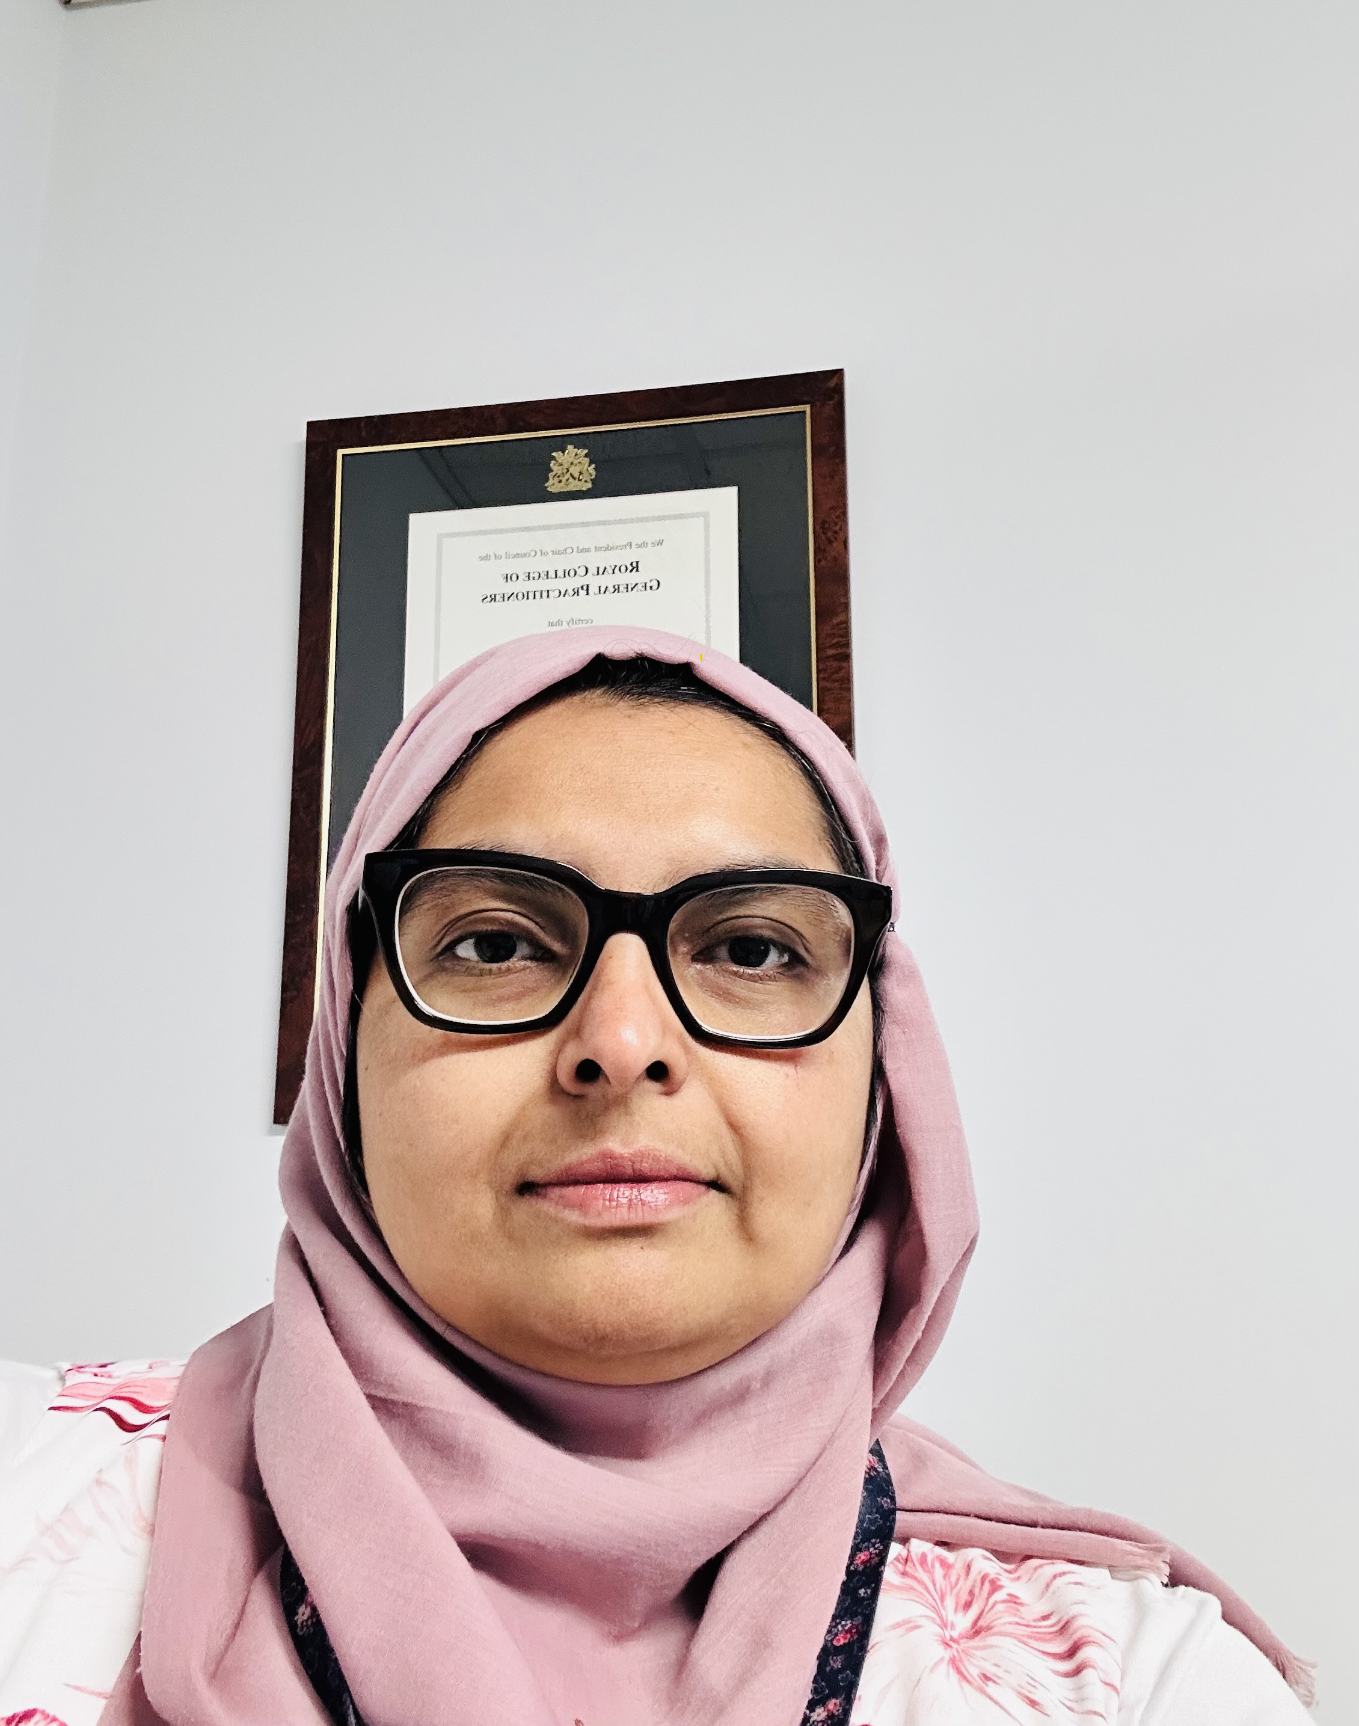 | Dr Kiran Qureshi  I’m a GP Partner practicing in Swanage. I have a special interest in clinical Dermatology. I am also a clinical supervisor and LMC representative for Purbeck .  I completed my GP training in Poole in 2016. Originally from Pakistan, I moved to the UK in 2002 and have been proud to call it home ever since. I believe we are very lucky to have the NHS . I love my work because it gives me the chance to support my patients day in and day out. Outside of practice, life mostly revolves around my young family, practising yoga and supporting various community groups.

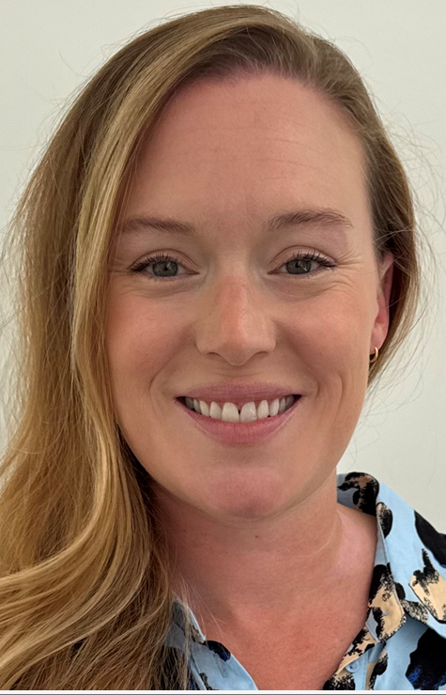 | Dr Alice Rollin  Alice Rollin is a salaried GP working in Christchurch, Dorset. After completing a degree in Psychology at the University of Bristol, she went on to study Medicine at the University of Oxford, graduating in 2014. She completed her GP training in Bristol, before moving back to the south coast - where she grew up - with her young family. Alice enjoys spending time with family and friends, and enjoying the beach and forest.

Dr Harry Gemmell
Biography and photo awaited

