Dorset LMC 2026-2028
Introducing your local Sessional LMC Representatives….

 | Dr Nicola Prys-Jones  Dr Nicola Prys-Jones works as a portfolio GP in Poole and Bournemouth. She graduated as a doctor in 2004 and worked in all three major hospitals in Dorset before qualifying as a GP in 2009. Having previously been employed as both a salaried and then a retainer GP locally, Nicola currently works as a locum GP, provides weekly out of hours shifts in UHD Urgent Treatment Centre and is a GP Appraiser. She really enjoys the variety of presentations and diagnostic challenges general practice provides and is a passionate advocate for General Practice and her fellow GPs. Nicola has previously held the role of Vice Chair on Dorset LMC and continues to be the Sessional representative on Dorset LMC.

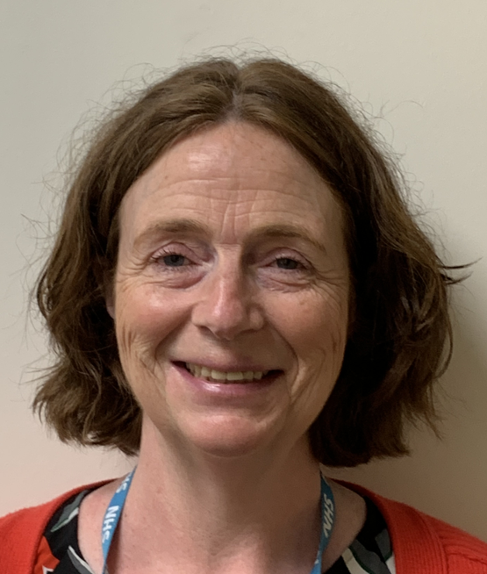 | Dr Paula Barrett  Dr Paula Barrett is a sessional representative on Dorset LMC. She graduated in 1993 and completed her GP Vocational Training Scheme (VTS) in Bath in 1997. After gaining experience in a variety of general practice roles in London and Surrey, she has spent the past two decades working in Dorset.  Paula currently works as a portfolio GP, combining locum and regular out-of-hours work with roles as a GP appraiser, coach and mentor, and facilitator and examiner for Southampton Medical School. She is passionate about supporting GPs at every stage of their careers and promoting general practice as a rewarding and fulfilling profession. Alongside her educational and leadership roles, she continues to enjoy the clinical challenges and conundrums of everyday primary care.

