Dorset LMC 2026-2028
Introducing your local Weymouth & Portland LMC Representatives

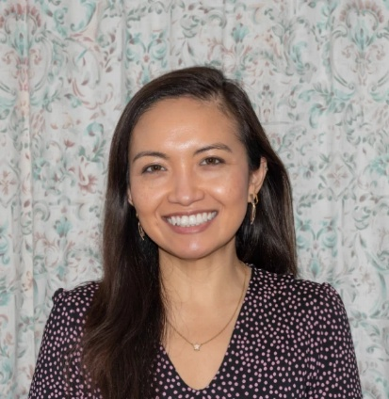
Dr Sharlina Sallehuddin
I have been a GP Partner at Royal Crescent Surgery (now part of Weymouth Bay Medical Practice) since January 2020. I am also a GP Trainer, and I dedicate part of my working days training new GPs. I have been the Weymouth and Portland representative for the Wessex Local Medical Council since April 2022, and more recently, I am also the Federation Chair of Two Harbour Healthcare for the Weymouth and Portland Primary Care Network.

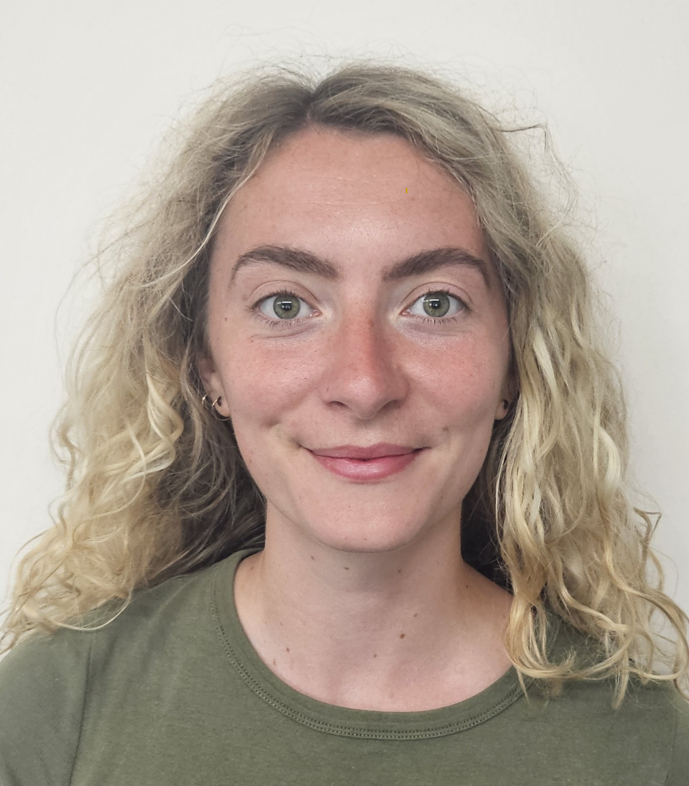 | Dr Cheska Ball  Cheska Ball is a Salaried GP and the clinician education program lead at The Bridges Medical Practice in Weymouth. She completed her Foundation and GP training in Dorset and has been active in local, regional and national advocacy for several years. She continues to shape policy as an elected member of both the BMA GP Committee (UK) and the RCGP Council. In her down-time she also loves designing escape rooms and running!

