Dorset LMC 2026-2028
Introducing your local West & Mid Dorset LMC Representatives

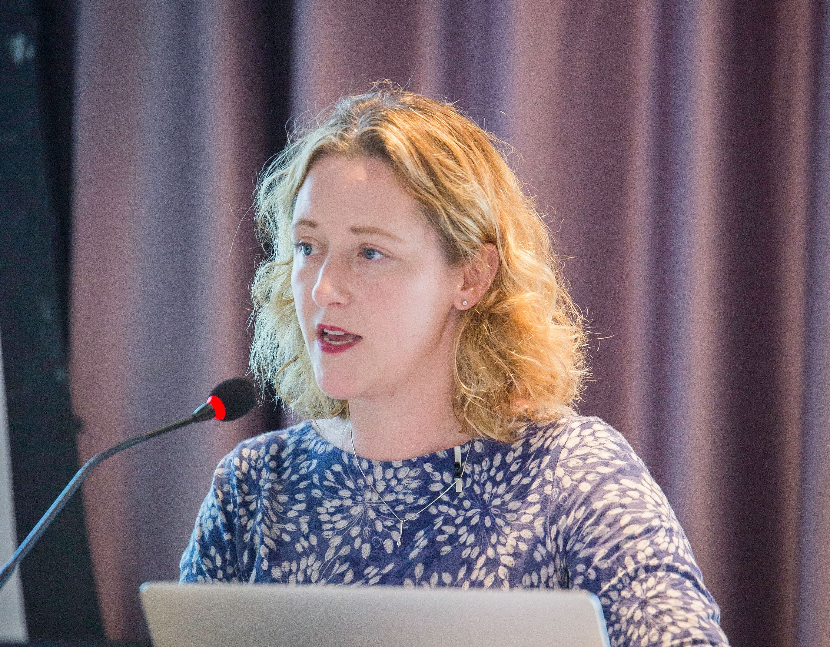 | Dr Sarah Kay  Dr Sarah Kay has worked in Dorset since 2007 and has been a GP since 2016.  She has a portfolio career- including working as a retainer GP in Weymouth, GP appraiser, Medical Examiner for West Dorset, and as a Bank GP in Community Hospitals and Appraiser for Dorset Healthcare Trust, and as the GP Clinical Lead for Quality and Patient Safety at NHS Dorset. She has been on Dorset LMC for a number of years and is keen to support the resolution of system problems that affect GPs and surgeries

 | Dr George Saw  Dr George Saw moved to West Dorset to join the GP training scheme, drawn by the area’s exceptional quality of life and enduring sense of living on holiday. Prior to relocating, he trained and worked in hospitals across Brighton and the wider Sussex region.  He is currently an eight-session GP Partner at Ammonite Health Partnership and serves as a Mid and West Dorset representative on Dorset LMC.  Dr Saw enjoys the generalism of general practice and values the variety and continuity it offers. He is passionate about supporting primary care and is committed to helping practices across Mid and West Dorset thrive, ensuring they deliver the highest standards of care for patients while fostering a sustainable and rewarding working environment for the workforce.  Dr Saw lives locally with his wife, son, and a smallholding of animals, which keep him fully occupied outside of work.

