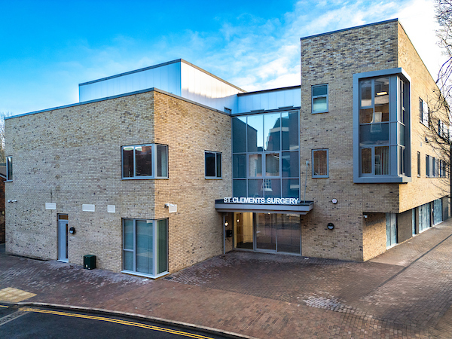

Salaried GP 4-6 sessions – fixed term contract
St Clements Surgery, in Winchester are looking for an enthusiastic GP to join our friendly & supportive clinical team. Initially, for a fixed term contract until March 2027.
We are an established teaching practice with over 16,000 patients and a strong focus on both excellent patient care, continuity of patient care, and staff development and well-being.
For over a year now, we have been in a brand-new (air conditioned) building, which is in the centre of Winchester City.
Why St Clements?
- Work alongside 8 GP Partners, 5 Salaried GPs, 2 Retainer GPs, 3 GP Registrars, 3 ANPs, Practice Nurses and HCAs.
- We are also part of a strong city centre PCN, encompassing a broad multidisciplinary team of clinical pharmacists, first contact physiotherapists, visiting paramedics, proactive care visiting nurse and social prescribers.
- 15-minute appointments for all routine face to face and telephone consultations
- Weekly clinical meetings, a culture of learning and development and daily morning team coffee breaks for collaboration.
- Good CQC rating and high QOF performance
- EMIS Web & Docman systems
- Most home visits are covered by our visiting paramedic
Your Role
- If 6 sessions per week - 4 will be routine and 2 will be urgent/duty clinics per week.
What we offer
- Competitive salary based on experience.
- 10 sessions of study leave per year.
- Full Medical Indemnity paid.
- A very supportive environment for both newly qualified & established GPs
- Staff carpark
How to apply - If you would like more information or to arrange an informal visit, please contact Fay Johnson, Practice Manager via email, fay.johnson1@nhs.net

