Dorset LMC 2026-2028
Introducing your Practice Manager Invitees…….

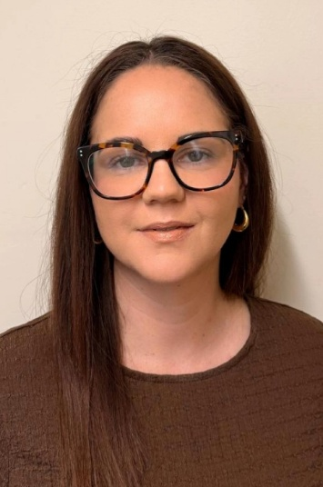 | Natalie McPherson  I began my career in medical accountancy, where I spent 12 years building a strong foundation in finance before making the leap into General Practice in February 2020, just six weeks before the world changed with the pandemic! It was a big transition, but one that quickly became both rewarding and fulfilling.  In 2021, I stepped into the role of Practice Manager much earlier than I had ever expected in my NHS journey, and then in June 2022, I was delighted to be invited to become Managing Partner. It’s been an incredible experience, full of learning, challenge, and growth.  One of the moments I’m most proud of is our Practice’s journey following a ‘Requires Improvement’ CQC rating in October 2022. Thanks to the hard work, resilience, and genuine team spirit of our staff, we turned things around and achieved an ‘Outstanding’ rating in August 2025. It’s a true reflection of what can be achieved when everyone pulls together with a shared purpose.  Outside of work, I love getting outdoors for a walk, as well as keeping active with Pilates and yoga—occasionally topped off with a relaxing gong bath!  I’m really looking forward to becoming a Practice Manager Invitee with Dorset LMC. I’m a passionate supporter of the LMC and the fantastic work they do to champion and support General Practice, and I’m excited to get more involved.

 | Carolyn Hattersley  I started my General Practice career as a Finance Manager in a dispensing practice in rural Herefordshire. As is often the case in general practice I was gradually given more responsibility and took up the role of Practice Manager 5 years later. I was pleased to be part of a team which achieved a CQC Outstanding Status in 2020.  Later that year we had a family move to Dorset and I managed Orchid House Surgery in Ferndown for 2 years.  I joined The Adam Practice in Poole in 2022 as Business Manager and recently as Managing Partner.

