Dorset LMC 2026-2028
Introducing your local Poole LMC Representatives ……..

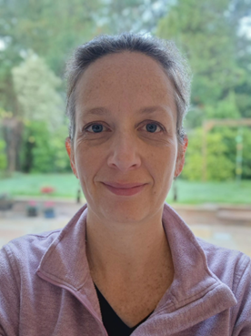
Dr Sara Cabrini
I’ve been a GP Partner since 2018, and for the past five years I’ve worked closely with our operational management team. This has given me a good insight into the everyday pressures and bureaucratic hurdles that practices face. I have great respect for the hard work our LMC board does in representing us to the “powers that be,” and I’d really like to hear your thoughts and concerns as members of the primary care team so I can take them forward to the LMC committee.

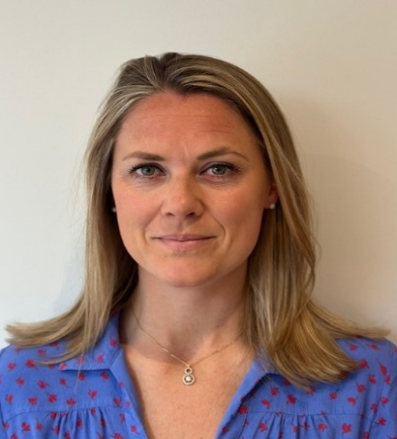 | Dr Leanne Eddie (Vice Chair)  Leanne Eddie is a salaried GP working in Westbourne, Dorset. She completed her first degree in Physiotherapy at the University of Southampton, before going on to study Medicine at the University of Bristol, graduating in 2013. Leanne completed her GP training in Kingston & Roehampton VTS after a couple of years of work and play in Melbourne, Australia. When not at work, Leanne enjoys training for that next running or open water swim event, and spending time with her young family.

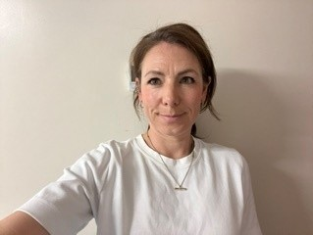 | Dr Emma Evans  Emma is a GP Partner working in Rosemary Medical Centre, Poole since 2014. She graduated from University of Southampton Medical School in 2003, before undertaking training jobs locally in Poole, then New Zealand, before GP training in Manchester. In 2010 she returned to Dorset as a GP , undertaking locum, and OOH roles before becoming a Partner. Since then she acquired a husband & 3 children so is still working on finding the work/life balance! However, when able she enjoys running, catching up with friend’s and planning her next travels … albeit family friendly ones

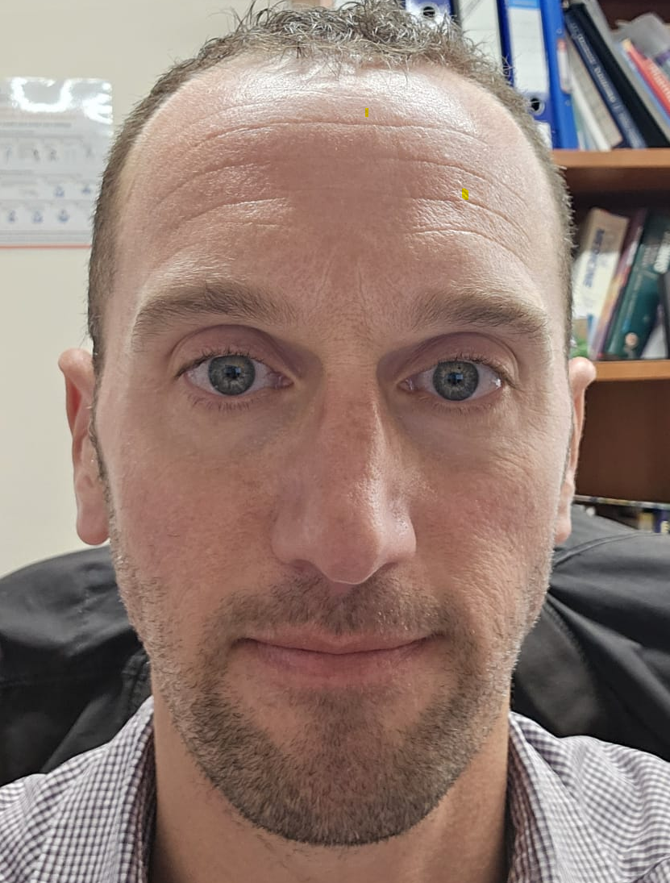 | Dr David Broadley  For more than 20 years, I have worked as a doctor across Bournemouth and Poole, building a broad understanding of the opportunities and challenges facing local general practice and the wider NHS. Since 2010, I have been a GP Partner at Rosemary Medical Centre, I am practice lead and the CQC registered manager.  Alongside my clinical work, I have held a number of leadership roles across primary and secondary care. These have included serving as Clinical Director of Poole Central PCN, CCG Clinical Lead for Paediatrics, and Medical Director of Integrated Care at UHD. Through these positions, I have gained extensive experience in collaborative working, service development, and representing the interests of both patients and clinicians across the healthcare system.  As a Wessex LMC representative, I am passionate about being a strong advocate for primary care. I believe it is essential that general practice has a clear and influential voice during a time of increasing demand and change within the NHS. I am committed to listening to colleagues, supporting practices, and ensuring that all Poole GP practices are effectively represented.  Outside of medicine, I am married to Alison, and we have three children aged 10, 11 and 14. My great passion is running, and I currently hold a marathon personal best of 2 hours and 31 minutes. One of my favourite achievements remains beating Paula Radcliffe in the London Marathon.

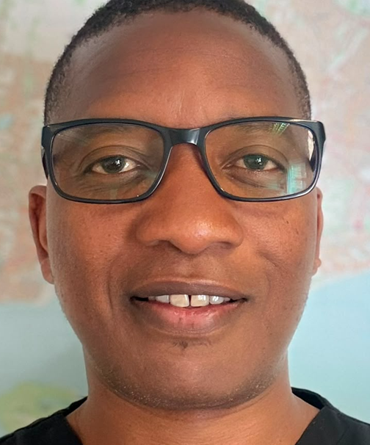 | Dr Farai Chimbwanda  Farai is a GP Partner who graduated from the University of St Andrews in 2009 and completed his medical degree at the University of Manchester in 2012. He undertook both his Foundation Training and General Practice Specialty Training locally in Poole and Bournemouth. Farai has developed a strong commitment to both patient care and the advancement of primary care services. He has a particular passion for medical education and contributes extensively as a GP Trainer, supervisor for medical and allied healthcare students, and Clerkship Director for St George’s University, Grenada. Outside of work, he enjoys cycling and touch rugby.

