Dorset LMC 2026-2028
Introducing your local North Dorset LMC Representatives…..

Awaiting Photo | Dr Martin Longley  I am an experienced GP who has been at the forefront of primary care for many years. I have held various roles from Governing body member of the CCG to Associate Medical Director at DCHFT for primary care. My areas of interests are cardiovascular disease, I was the ICB clinical lead for this and am the primary care lead for the south west renal network, and particularly integrated car. I was a GP trainer for 25 years.  My surgery pioneered integrated Nurse teams - 30 years ago so I am invested in this and see the value of neighbourhood team development. INT helped us get an outstanding rating at CQC and win “surgery of the year at the national GP awards  I used to enjoy long distance triathlons - I am an Ironman! and my unusual fact is that I had to write a letter of apology to the Late Queen Mother who I kept awake with my singing. .  I will endeavour to represent primary care to the best of my ability to ensure our voices are not only heard but influence the direction of travel.

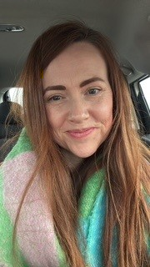 | Dr Rebecca Lye  Rebecca Lye is a GP Partner working in Sherborne, North Dorset. She graduated from Leicester Medical School in 2014 before moving ‘home’ to Somerset in 2016 and completing GP training on the Dorset VTS in 2022. When not at work Rebecca loves to travel with her husband and young family, she is always planning their next adventure.

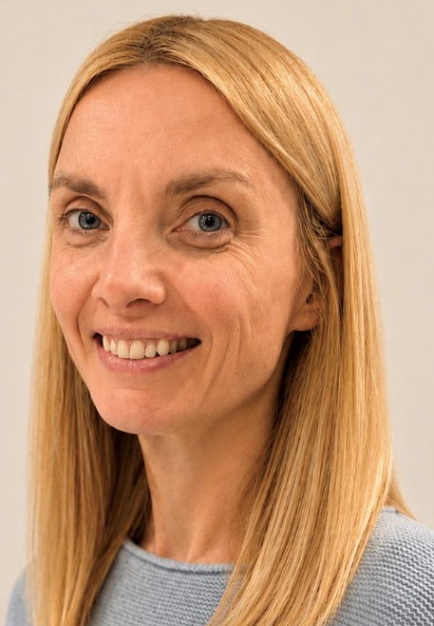 | Dr Kathryn Armitage  Kathryn Armitage is a GP Partner in Yetminster, near Sherborne. Originally from Wimborne she qualified from Manchester University and originally trained as a respiratory physician before moving home to Dorset and retraining as a GP. She also works for Wessex Cancer Alliance as a GP advisor.  Outside work activities involve watching or taking part in all things sport related. A keen follower of test match cricket her most prized possession is a signed photograph of Michael Atherton.

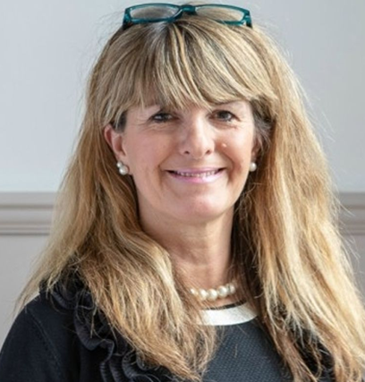 | Dr Simone Yule  Simone qualified in medicine in Cardiff in 1991 and completed her GP training in Dorset. She has been practicing at The Blackmore Vale Partnership for the last 30 years. She is a Senior Partner, Clinical Director and Dorset LMC Committee member. She is also the Primary Care Place lead for Dorset and is supporting neighbourhood development and the National Neighbourhood Health Implementation Programme.

