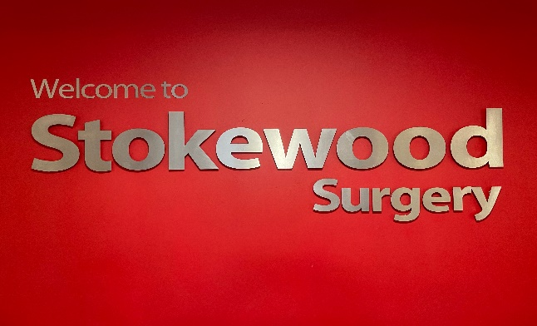

Stokewood Surgery – Fair Oak, Eastleigh, Hampshire

4 session GP required to start Sept/Oct 2026

Are you a newly qualified GP ready to embark on your first permanent post? Look no further! Stokewood Surgery is thrilled to introduce our exclusive Newly Qualified GP Programme. Designed to smoothen your transition into a salaried role, this program is built on feedback from our experienced salaried GPs. Join us and kick-start your career with confidence!

What's in it for you? Let's break it down:

✓ Personalized mentorship: Benefit from regular meetings with a dedicated mentor, one of our esteemed GP partners.

✓ Gradual progression: We understand the importance of easing into your role. Enjoy a reduced patient list and a gradual introduction to duty sessions.

✓ Primary Care Fellowship: As a salaried GP you will be eligible to take part in this programme offered by Health Education England, we would fully support your application and participation.

Program Snapshot:

Month One:

Engage in weekly 1-hour meetings with your designated mentor.
Manage a restricted patient list size of 100 patients per session
No lead duty doctor or eConsult sessions.

Months Two and Three:

Continue with weekly 30-minute meetings with your mentor.
Manage a slightly expanded patient list size of 150 patients per session
No lead duty doctor or eConsult sessions.

Months Four

Maintain weekly 30-minute meetings with your mentor.
Manage a slightly expanded patient list size of 200 patients per session
No lead duty doctor or eConsult sessions.

Month Five and Six:

Maintain weekly 30-minute meetings with your mentor.
Take charge of a fair share patient list (capped at BMA max of 275 patients per session).
No lead duty doctor or eConsult sessions.

After six months, you'll be fully equipped to embrace our standard job description for experienced salaried GPs.

Job Opportunity:

Position: 4 Sessions per week - 4 salaried (as per newly qualified scheme)

Salary: Up to £12,655 per session per annum

Why Choose Stokewood Surgery?

✓ Supportive environment: Join our friendly practice where GPs gather for daily catch-ups over coffee.
✓ Mentorship & assistance: Benefit from a GP partner mentor and an allocated PA/Med Sec.
✓ Prime location: Conveniently located in Fair Oak, within the Borough of Eastleigh. Easy commute from Winchester, Southampton, and Romsey.

What Sets Us Apart:

✓ Efficient appointments: 15-minute appointments, 14 per session with no extras.
✓ Reduced urgent visits: Home visits managed by our expert Urgent Care Response Team & paramedics.
✓ Extended hours access: Although based in the Practice, there is currently no requirement for our salaried GPs to cover these hours.
✓ Work-life balance: Enjoy 6 weeks of annual leave and one week of study leave (pro rata).
✓ Streamlined workflows: Our document workflow screening minimizes GP letters.
✓ Active engagement: Participate in fair share duty sessions and become a list-holding GP.
✓ Strong team: Collaborate with our dedicated team, including partners, salaried GPs, Advanced Nurse Practitioners, paramedics, MSK physios, clinical pharmacist, practice nurses, healthcare assistants, and supportive administrative staff.
✓ Continuous learning: Take advantage of our in-house Education program, mentorship, and engaging meetings with clinical experts.
✓ Training focus: As a training practice, we host registrars and medical students.
✓ Research-driven: Join our research-active practice.
✓ Competitive package: PMS contract with a salary of £12,000 per session per annum + indemnity fees.
✓ Patient base: Current list size of 19,000 patients.
✓ Modern facilities: All rooms equipped with dual screens.
✓ Technology-driven: We use EMIS Web, Docman, and ICE.
✓ Network participation: Proud member practice of the Winchester Rural South PCN.
✓ High standards: CQC Rated Good (August 2020).
✓ Fuel up: Enjoy our monthly Pizza lunch!

Ready to take the leap? Contact Chris Whatley, Practice Manager, at c.whatley1@nhs.net or Tori Brown, Operations manager at v.brown7@nhs.net for more information or to arrange a visit.

Join Stokewood Surgery and embark on a remarkable journey towards a fulfilling GP career! Act now!

