Dorset LMC 2026-2028
Introducing your local Bournemouth LMC Representatives…

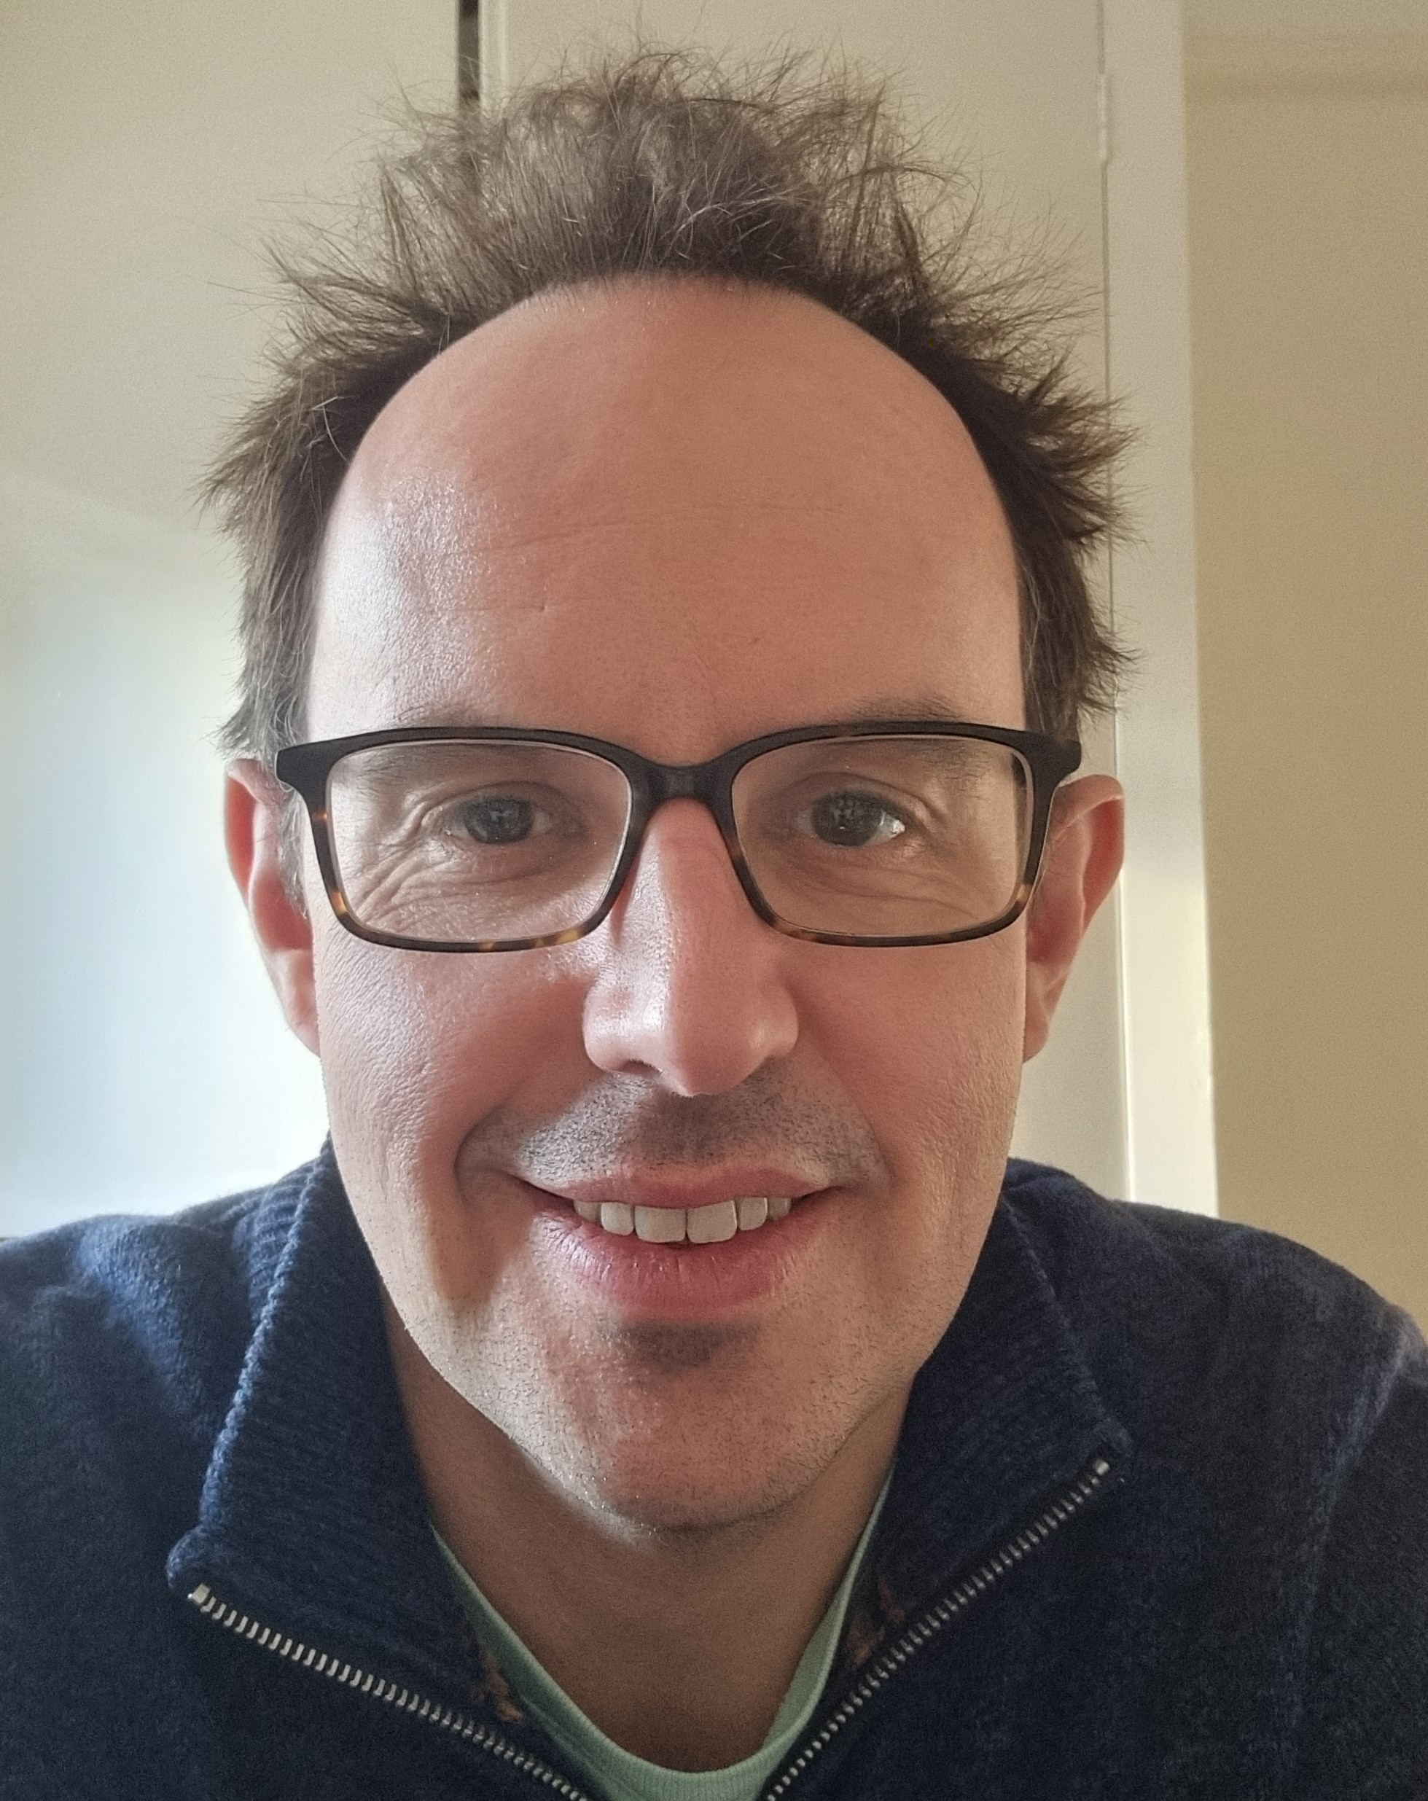 | Dr Nick Aldred  Nick has been a full-time partner at Talbot Medical Centre for over 10 years. He came down to Poole in 2011 after a circuitous route into medicine by way of a degree in Physics and 8 years working in the city in Quantitative Equity Research before deciding on Medicine instead. Having had a career before Medicine, Nick feels well placed to put the ups and downs of our career into a wider context but feels passionately that GPs need to stand up and make our voices heard. At work, he is a strong advocate for the power of IT to make our (and our patients’) lives better but cautious about the potential for the tail to wag the dog and feels that the increasing ‘industrialisation’ of Medicine is no-one’s friend. Inherently an optimist, he is still hopeful that UK General Practice can be saved but feels we are running out of time to do it and that we will need to make some tough decisions to make on the way.  Outside of work, podcasts such as The Rest is History, Radical with Amol Rajan, Sideways (Matthew Syed) and anything with Rory Sutherland are often playing in the background. His wife is also a local GP. He enjoys tennis, cycling, sailing with the children, reading and cooking.

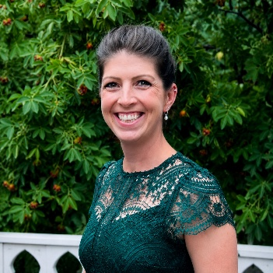 | Dr Emma John  Emma John is a GP working in Bournemouth, Dorset. She graduated from Aberdeen University in 2010. Initially she trained in Obstetrics and Gynaecology before retraining as a GP with a focus on women’s health. When not at work Emma enjoys being active outdoors, running, slowly completing the Southwest Coast path and spending time with her family.

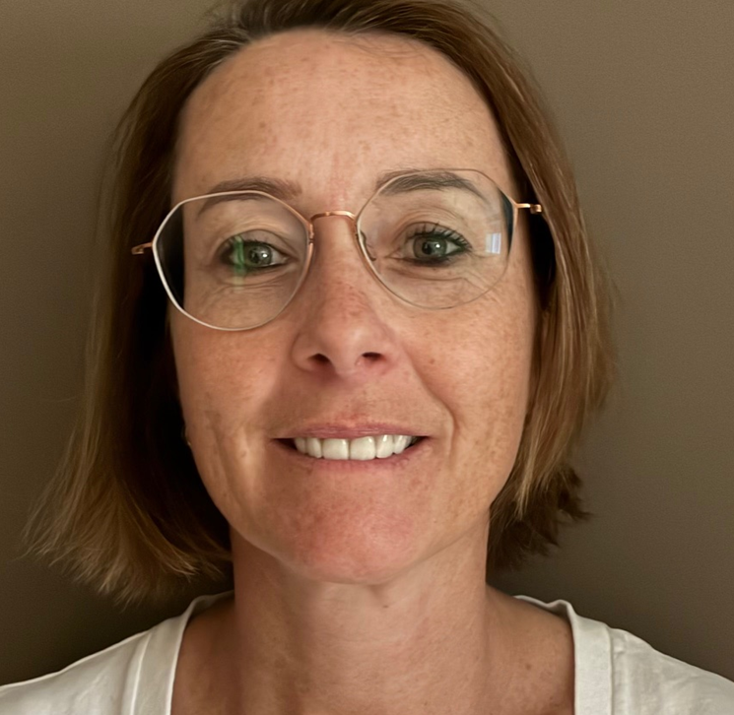 | Dr Hannah Wells  Since qualifying as a GP in 2008, I have developed a broad and varied clinical career, underpinned by a strong background in general medicine. I have worked across Dorset as a locum, retainer and salaried GP, alongside roles in gastroenterology clinics and community hospitals, including St Leonard’s Hospital.  Since 2015, I have been based at CresProvidence Surgery in Boscombe, where I continue to provide comprehensive primary care within a diverse community. Alongside my practice role, I have been actively involved in urgent and integrated care services, working regularly in GP triage within Accident & Emergency departments and at walk-in centres.  I previously served on the board of Improved Access to General Practice, contributing to the development and delivery of accessible primary care services across the region.  My professional interests include women’s health, general medicine and neurodiversity. I am particularly passionate about patient safety, clinical accountability, and improving the interface between primary and secondary care.  For the past five years, I have served on the Dorset LMC, advocating for both patients and clinicians while supporting sustainable, high-quality general practice.

Dr Ravin Ramtohal
Awaiting biography

