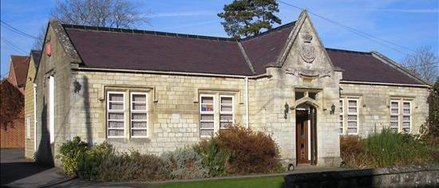

Salaried GP position

An opportunity to join our small, friendly and supportive team in beautiful Great Bedwyn, where we strive to provide traditional family medicine.

OUR MISSION STATEMENT
At the Old School House Surgery we provide a high standard of care for our patients in a holistic, inclusive and safe environment.
We seek to provide a welcoming and understanding practice which provides patient centred care within our community. We see ourselves playing a vital role in health promotion and empowering patients to take responsibility for their own health and well-being.
The practice aims to provide a happy, supportive and respectful place for staff. We believe that learning and teaching are key aspects of what we do as they enable us to drive the high standards of care and satisfaction.
To enact this, our chosen core values for our organisation are:
1. Kindness
2. Teamwork
3. Integrity

ABOUT US

- Dispensing practice serving around 3500 patients.
- Part of the East Kennet PCN.
- Long-established training practice for GP trainees as well as Bristol medical students.
- SystmOne clinical system.
- Visa sponsoring organisation.
- High QOF achievement.
- Good CQC rating.
- Veteran-friendly RCGP accreditation.
- Registered Parkrun practice.
- Registered mental health first aiders within the team.
- We offer minor surgery, joint injections, cryotherapy as well as LARC services.
- No nursing homes in our patch.
- We are pleased to have ARRS staff including Clinical Pharmacists, a Care Co-ordinator, a Health and Wellbeing Coach and a GP Assistant.

THE JOB

- Very well supported by two GP partners.
- Five sessions per week:
Wednesday – 2 sessions
Thursday AM – 1 session
Friday 2 sessions
- 15-minute appointments.
- No duty sessions.
- Opportunity to teach if desired.
- BMA model contract.
- Professional indemnity fees and appraisal package subscription included.
- Daily mid-morning coffee break with the clinical team.
- Whole practice meetings, significant event meetings, palliative care meetings.
- Designated off-street staff parking area.

THE LOCAL AREA

- Situated by the Kennet & Avon canal in the North Wessex Downs, an area of Outstanding Natural Beauty.
- Direct train links to London from the village and nearby motorway links.
- Excellent local schools.
- Nearby historic Savernake Forest and the market towns of Marlborough and Hungerford.
- Lovely village store with post office and bakery adjacent to the practice.

We have very high patient satisfaction, a stable population and enjoy good continuity of care with our patients. We welcome anyone who is interested to come and see for yourself what a special place our surgery is – an informal visit can be arranged.

Please apply by sending your CV with a covering letter to our Practice Manager Nicky Johnson nicky.johnson@nhs.net by Friday 27th February 2026.

