Positions: Salaried GP Role and GP Maternity Cover Role
Hours: 3-6 sessions with flexibility, available now.
Opportunity to work across our 2 sites with a wide range of team members/professionals

Come and join us in beautiful North Dorset!  We are a high earning, innovative and friendly partnership working across 3 sites embracing the beautiful market towns of Sturminster Newton and Shaftesbury with excellent local schools, transport links and are only 45 mins from the Jurassic coast. | 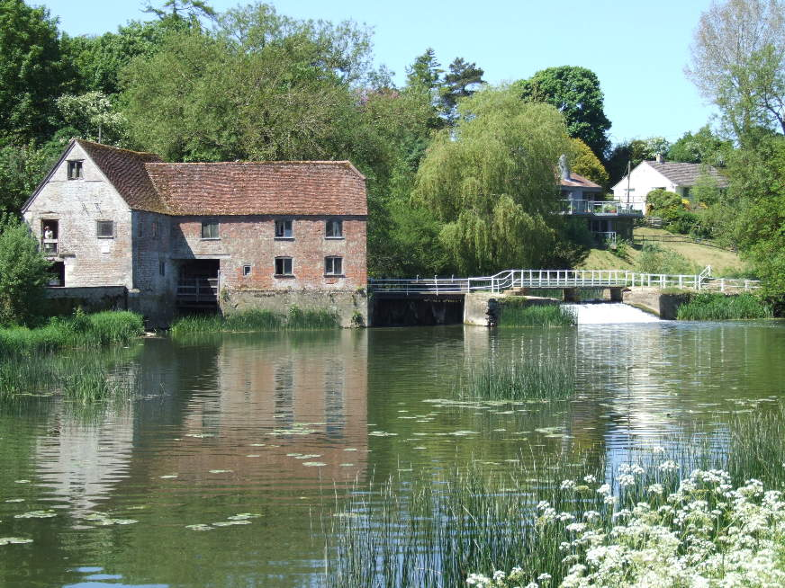
- 27,000 patients
- 9 partners; democratic and MDT partnership
- Superb practice team including salaried GPs, retained Doctors, ACPs, full practice nurse team, Medicines Management team, wellbeing team and supportive administration members
- Physio FCP, Mental Health support and social prescribing team
- Frailty team including AHPs, HCAs
- Training practice linked with UCL, Bristol and Imperial Universities
- Expanding research opportunities
- Good CQC rating

We currently have an exciting opportunity for GP’s to join us for both a GP maternity leave cover (3-4 sessions) and a substantive salaried GP role (6 sessions)to join our innovative team.

We have been part of the nationally recognised Altogether Better Programme and have a fantastic multi-disciplinary team which includes a great practice and frailty nurse team, social prescribers, health coaches, and a digital care co-ordinator who are developing a really holistic and patient focused approach to health care.

We are part of the Complete Care Community national pilot, working in partnership with local organisations to reduce social isolation following Covid-19, and are developing a frailty long term condition pathway, embracing digital options where appropriate and helpful. We also operate a continuity of care approach, trying to improve continuity for are more frail and complex patients.

As a partnership we welcome the opportunities to support our workforce as individuals and recognise the benefit of flexible working. We are a fun-loving group with a great sense of humour. We are looking to expand our partnership model and welcome you to give us a call and come and visit this beautiful part of the world. www.blackmorevalesurgery.co.uk

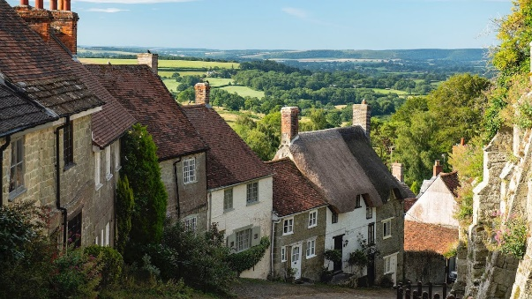 | For an informal chat please ring Dr Simone Yule  07811083289  Simone.yule@dorsetgp.nhs.uk

