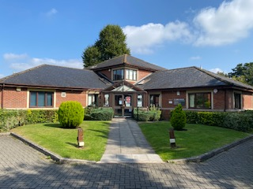
ST JAMES SURGERY DEVIZES

4 SESSION GP

£11500 - £12500 PER SESSION/YR

NO DUTY SESSIONS

Email: Tracy.harris2@nhs.net
Call :01380 711879

We are looking for a 4 session GP including 2 sessions on Fridays.

You will join a very welcoming training practice consisting of 3 GP Partners and 2 Associate GPs, ANP, Nurses, Physician Associates, Pharmacist, HCAs & FCPs.

All acute care shared by Devizes PCN at the Devizes Health Centre – Duty days where you are the only GP on duty are a thing of the past in Devizes!

Key Information:

- Salary negotiable dependent upon experience
- BMA Model Contract
- Average 15 appointments per session – mix of 10 minute telephone and 20 minute F2F clinics.
- Urgent Care shared amongst Devizes PCN colleagues within an Urgent Care Team.
- 6 weeks Annual leave + 1 week study leave
- Document management dealt with mostly by administrative team
- Paramedic/ECP Home visiting service – so virtually no visits for you
- Lots of cakes and biscuits, lots of laughs, come and join us, you won’t regret it!

Please send CV to Tracy Harris – Practice Manager, St James Surgery, Gains Lane, Devizes, Wiltshire, SN10 1QU. Email: Tracy.harris2@nhs.net or for an informal chat 01380 711879

