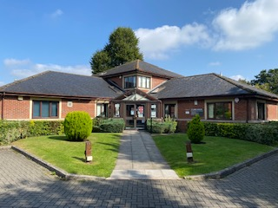

ARE YOU AN ENTHUASTIC GP - WE WANT YOU TO WORK WITH US IN DEVIZES

Residing in the heart of beautiful, historic Wiltshire; St James Surgery is located in Devizes. Bristol, Bath, Swindon and Salisbury are close by with good transport links to the rest of the County. We are looking for a 2 session GP to work on Friday. You will join a very welcoming practice consisting of 3 GP Partners and 3 Associate GPs, ANP, Nurses, Physician’s Associates, Pharmacist, HCAs, FCPs.

We are a friendly, supportive, forward-thinking practice with over 7300 patients. We have a wide multidisciplinary team with some practitioners employed to work across the very successful Devizes PCN. Come over to St James for an informal chat and experience the atmosphere of working in a brilliant team environment.

- Salary (£10.5 - £12k) dependent upon experience
- BMA Contract
- Average 15 appointments per session
- Mixed telephone and F2F clinics
- 20-minute F2F
- 2 sessions per week but we are happy to negotiate family friendly hours or a term-time only contract
- Annual leave, study leave and one session for appraisal
- All acute care shared by PCN at the Devizes Health Centre with occasional
Rota duties
- Very experienced HCAs and administration team - Document management dealt mostly by administrative team
- Paramedic/ECP Home visiting service – so virtually no visits for you
- Practice MDT meetings
- Excellent QOF achievement year on year
- Regular educational meetings and mentoring
- TPP SystmOne clinical System
- Coils, implants and Minor Surgery
- Community Care Co-ordinators
- Community Connector (Social Prescriber)
- Lots of cakes and biscuits, lots of laughs come and join us, you won’t regret it!

Please send CV to Tracy Harris – Practice Manager, St James Surgery, Gains Lane, Devizes, Wiltshire, SN10 1QU. Email: Tracy.harris2@nhs.net or for an informal chat 01380 711879
Closing date: open

