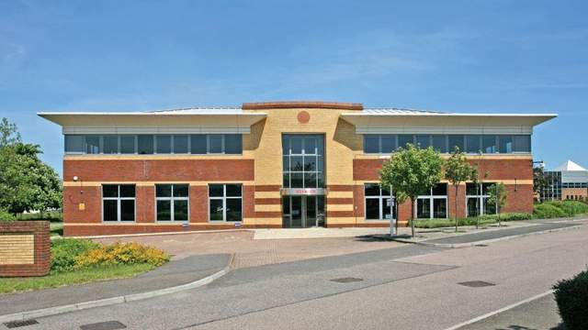


Join Our Forward-Thinking GP Team in Farnborough

We are seeking a motivated Salaried GP (6 sessions) to join our dynamic, supportive, and friendly team caring for nearly 20,000 patients in a thriving, purpose-built practice on the Hampshire/Surrey border.

Why Join Us?
- Work in a state-of-the-art building co-located with community nursing, integrated care, midwifery, paramedic home visiting, and the North Hants Urgent Care centre.
- Be part of a stable, respected training practice with an emphasis on innovation and career development.
- Benefit from our Total Triage system, designed to ensure fair access, manage demand safely, and support GPs in focusing on clinical priorities.
- Enjoy our unique care model: separating urgent “on-the-day” demand from routine care — giving you time to deliver continuity for patients with complex needs.
- Thrive in a multi-disciplinary team including Nurse Prescribers, Paramedic Practitioners, Physician Associates, Mental Health Practitioners, Clinical Pharmacists, Physiotherapists, and a fantastic admin team who keep things running smoothly.
- Benefit from our active Primary Care Network links — with >95% of home visits handled by a locality paramedic team, freeing you to focus on high-value care.
- Experience the balance we value: high-quality patient care + a sustainable work/life balance.

About You
We are looking for a GP who shares our commitment to clinical excellence, teamwork, and innovation, and who wants to contribute to the continued success of the largest - yet friendliest - practice in Farnborough.

If this sounds like the role for you, we’d love to meet you. Get in touch with our Practice HR & Training Manager for an informal chat over coffee and a tour of our purpose-designed premises: dawn.hambly@nhs.net https://voyagerfamilyhealth.co.uk

