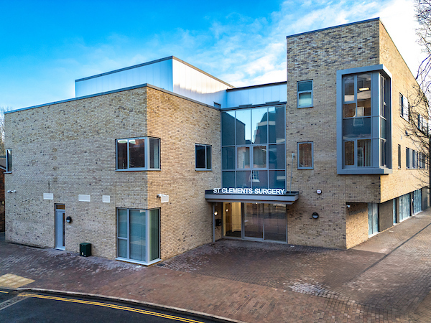

Salaried GP Vacancy (4-6 session list-holding)
St Clements Surgery, Winchester are looking for an enthusiastic GP to join our friendly & supportive clinical team.
We are an established teaching practice with over 16,000 patients and a strong focus on both excellent patient care, continuity of patient care, and staff development and well-being.
Early this year, we have just moved into a fantastic, brand-new building, which is in the centre of Winchester City.
Why St Clements Surgery?
- Work alongside 7 GP Partners, 4 Salaried GPs, 2 Retainer GPs, 2-3 GP Registrars, 2 ANPs, Practice Nurses and HCAs.
- Be part of a strong city centre PCN encompassing a broad multidisciplinary team of clinical pharmacists, first contact physiotherapists, visiting paramedics and social prescribers.
- 15-minute appointments for all routine face to face consultations
- Weekly clinical meetings, a culture of learning and development and daily morning team coffee breaks for collaboration.
- Good CQC rating and high QOF performance
- EMIS Web & Docman systems
- Most home visits are covered by our visiting paramedic
Your Role
- 4-6 sessions per week of which there will be a mixture routine and urgent/duty clinics per week. List holding approx. 1000-1500 patients.
What we offer
- Competitive salary based on experience.
- 10 sessions of study leave per year. (Plus, your Birthday off as extra leave.)
- Full Medical Indemnity paid.
- A very supportive environment for both newly qualified & established GPs
- Staff carpark
How to apply

If you would like more information or to arrange an informal visit, please contact Fay Johnson, Practice Manager via email, fay.johnson1@nhs.net

