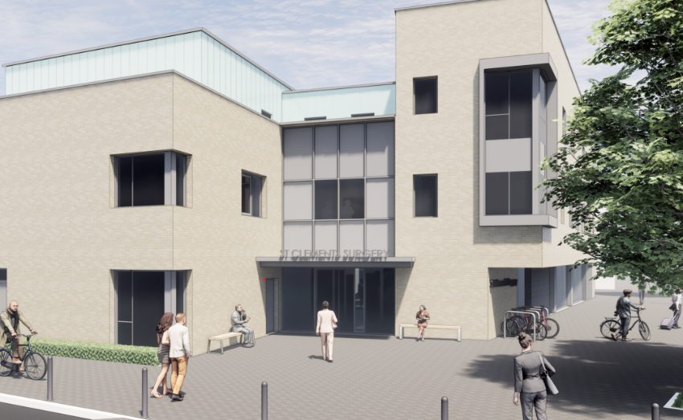

Advanced Nurse Practitioner
St Clements Surgery, Winchester

We have a fantastic opportunity to join a forward-thinking and popular teaching practice in the heart of Winchester City. We are looking to increase our current Advanced Nurse Practitioner compliment and would welcome enthusiastic & experienced practitioners to join our friendly and dedicated team of staff. You would be working alongside GPs, ANPs, visiting paramedic, nursing staff, HCAs, and PCN ARRs roles.

The role:
- To be part of our urgent on-the-day duty team. To work as an autonomous practitioner providing high quality patient care.
- It will involve undertaking telephone triage and face-to face appointments for those presenting with minor or acute same day problems.
- Full-time, flexible over 4-5 days. However, we will also consider part-time applications.
- Experience in primary care is essential.
- We encourage & support the development of special interests with 5 days of study leave per annum.
- Regular clinical supervision and support with an allocated GP Mentor.
- Salary dependant on experience.

The Partnership:
- There are currently 7 GP partners, 6 salaried GPs, 2 ANPs, a nursing team of 4 Practice Nurses & 3 HCA’s, and a large reception/administration support team.
- We are a GMS practice with high achieving QOF and enhanced services. Just over 16,000 patient list. We have an outreach clinic for Pilgrims boarding school, and a local service for homeless and vulnerably housed people.
- Long standing training and teaching practice.
- EMIS web clinical system, Docman, accuRx triage and Lexacom system.
- We are a very friendly, sociable, and approachable team.
- We place a high value on work-life balance and mutual support.
- Daily clinical coffee break at 11am, weekly clinical educational/training lunchtime meeting and monthly paediatric consultant clinic.

- We are part of a strong, progressive city centre PCN with 2 other practices. The current PCN roles include a large pharmacy team, visiting paramedics, MSK practitioners, social prescribers, Advanced Mental Health Practitioner, and an Enhanced Access Service.
- Informal visits prior to application are welcomed & encouraged.

How to apply:

To apply or to arrange an informal visit, call or for any further information, please email Fay Johnson, Practice Manager fay.johnson1@nhs.net

Email applications to include an up-to-date CV, and a covering letter.

Closing date: Friday 15th August 2025

Essential Qualifications:

Registered Nurse with Nursing and Midwifery Council

Master’s degree required for qualification post December 2020 – refer to RCN Credentialing for Advanced Level of Nursing Practice.

Post graduate diploma or degree for Advanced Practice Qualification up to December 2020

Qualified Independent Nurse Prescriber on the NMC register

Meets NMC revalidation requirements in accordance with the NMC Revalidation booklet

Meets the standards for registered ANP working at advanced level

