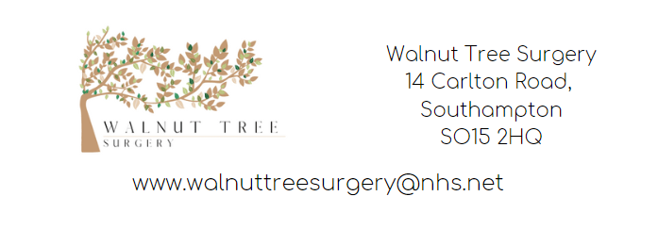
Advanced Nurse Practitioner - SOUTHAMPTON
Location: Walnut Tree Surgery, 14 Carlton Road, Southampton SO15 2HQ
Website: www.walnuttreesurgery.nhs.uk
Planned start date: 22nd September 2025
Pay range: £26 - £35 per hour (negotiable based on experience)
Set days: Tuesday afternoon (13:00 - 18:30), Thursday all day (09:00 - 18:00), Friday all day (09:00 - 18:00)
Contact details: Email: lisa.hoe@nhs.net Telephone: 02380333326
Overview
We are looking for an advanced nurse practitioner to join our fun, friendly and dynamic team.

What we offer:
- 3 partners, 1 ANP, 1 practice nurse and 2 HCAs.
- Well established small city centre practice looking after 4500 patients.
- Very low turnover of staff with our staff’s wellbeing the centre of our values.
- Partners have an open door policy.
- No lone working and no weekend work.
- NHS pension scheme
- 5 weeks annual leave (pro rota)
- SystmOne practice
- CQC rating Good in all areas

Requirements:
- A recognised Advanced Nurse Practitioner qualification who can prescribe independently.
- Looking for someone who is an excellent team player, who can work independently and offer us flexibility in a well-supported environment.
- The role would include working within a team offering same day care and chronic disease management to our patients through face to face and telephone appointments. You would be expected to be able to assess a patient autonomously, prescribe any necessary medication and formulate a safe management plan.
- The role would include supporting other members of the clinical team through leadership and mentorship.

Benefits:
As part of the role, you will benefit from access to the NHS Pension Scheme, five weeks of annual leave (pro rata), and a range of wellbeing offers and staff discounts available to NHS employees, supporting your health, work-life balance, and financial security.
We invite qualified candidates who are passionate about delivering exceptional patient care to apply for this rewarding position within our organisation. We would also welcome an informal visit from any interested applicants, offering the opportunity to chat with our existing ANP and other members of the practice. If you have any questions or would like further information, please feel free to contact our Practice Manager, Lisa Hoe.

