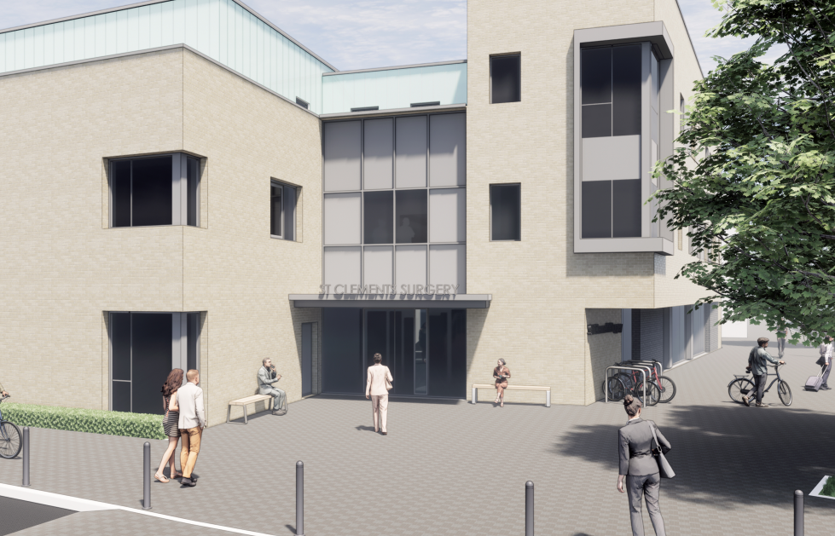
General Practice Nurse
Winchester City Centre
Employer: St Clements Surgery
Location: Winchester, Hampshire
Salary: Negotiable dependent on experience
Hours: Negotiable dependent on experience
Job Type: Permanent
Closing Date: Friday 13th June 2025

Job Summary

Our thriving city centre practice in Winchester is seeking a dedicated and experienced General Practice Nurse (GPN) to join our dynamic team. This role offers the opportunity to provide high-quality, patient-centred care with a focus on managing long-term conditions, particularly respiratory health. You will play a key role in expanding our services to meet the evolving needs of our diverse patient population.
About the Role
As a General Practice Nurse, you will:
- Deliver comprehensive nursing care in a primary care setting, with a focus on long-term condition management, especially respiratory care (e.g., asthma, COPD).
- Conduct patient assessments, develop care plans, and provide evidence-based interventions.
- Support health promotion, disease prevention, and patient education initiatives.
- Collaborate with GPs, healthcare assistants, and other professionals to ensure seamless patient care.
- Contribute to practice development and quality improvement initiatives.
This is an exciting opportunity to expand your scope of practice and make a meaningful impact in a growing practice.
About You
We are looking for a motivated and experienced nurse who:
- Is a Registered Nurse (RN) with current NMC registration.
- Has experience in primary care or varied post-registration experience in relevant clinical settings.
- Has a keen interest in managing long-term conditions, particularly respiratory illnesses.
- Possesses strong communication and interpersonal skills, with a commitment to patient-centred care.
- Can work independently and as part of a multidisciplinary team.
- Is enthusiastic about professional development and contributing to practice growth

What We Offer
- Flexible working hours to support work-life balance.
- Competitive salary, negotiable based on experience and qualifications.
- Opportunities for professional development and training, including support for further qualifications.
- A supportive and collaborative team environment.
- The chance to make a real difference in a growing practice dedicated to meeting the needs of our diverse patient population.

Why Join Us?
Our practice is located in the heart of Winchester, offering a vibrant and varied work environment. We are committed to innovation and excellence in primary care, and we value the contributions of every team member. This is an exciting time to join us as we expand our services to better serve our community.
How to Apply
If you are a skilled nurse looking for a rewarding role in primary care, we would love to hear from you. Please submit your CV and a cover letter outlining your experience and why you are interested in this opportunity to janedilloway@nhs.net. For an informal discussion about the role, contact Jane Dilloway, Nurse Practitioner on 01962 852211.
Application Deadline: Friday 13th June 2025
Join us in shaping the future of primary care in Winchester!

