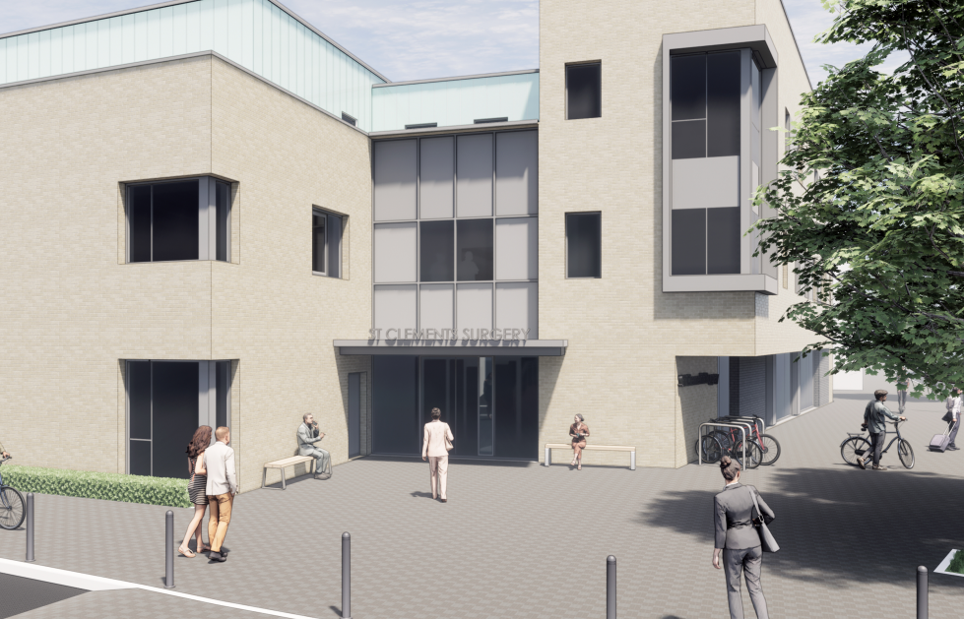

Health Care Assistant - Primary Care, Winchester City Centre
Location: St Clements Surgery, Winchester, Hampshire
Salary: Negotiable dependent on experience
Hours: Flexible, to be agreed
Job Type: Permanent
Closing date: Friday 13th June 25
Job Summary
We are a thriving primary care practice in Winchester city centre, dedicated to providing high-quality healthcare to our diverse patient population. We are seeking an experienced Health Care Assistant to join our growing team and contribute to our mission of delivering excellent patient care.
Role Responsibilities
- Assisting with clinical procedures and minor operations
- Performing routine diagnostic tests (e.g., blood pressure, ECGs)
- Administering vaccinations and supporting immunization programs
- Providing health education and promoting wellness initiatives
- Maintaining accurate patient records and ensuring confidentiality
- Collaborating with the multidisciplinary team to deliver comprehensive care
This role offers the chance to expand your scope of practice and develop new skills in a supportive environment.
Essential Requirements
- Proven experience as a Health Care Assistant in NHS hospital or community settings
- Strong clinical skills and patient care abilities
- Excellent communication and interpersonal skills
- Team player with a positive attitude and willingness to learn
- Flexibility to adapt to changing practice needs
- Commitment to providing compassionate, patient-centred care
What We Offer
- Competitive salary negotiable based on experience
- Flexible working hours to suit your lifestyle
- Opportunities for training and professional growth
- Supportive and collaborative work environment
- Chance to make a real difference in a growing practice
Equal Opportunities
We are an equal opportunities employer and welcome applications from all qualified candidates, regardless of age, gender, ethnicity, disability, or sexual orientation.
How to Apply
To apply, please submit your CV and a cover letter outlining your experience and why you are interested in this opportunity to janedilloway@nhs.net. For an informal discussion about the role, contact Jane Dilloway, Nurse Practitioner on 01962 852211.
Application Deadline: Friday 13th June 2025
Join us in shaping the future of primary care in Winchester!

