

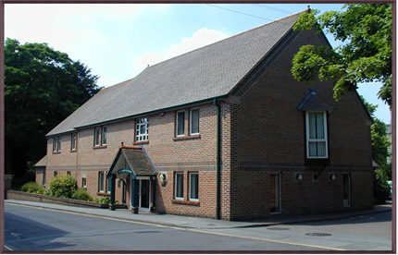

St Marys Surgery
Andover, Hampshire

Partnership Opportunity

or salaried position with a view to Partnership will be considered for the right candidate

Due to retirement an exciting opportunity has arisen for an enthusiastic, hardworking, and motivated GP to join our team. We require someone who will play an active role within the Practice to maintain our values and help develop patient services for the future. As a training practice we welcome applications from GP Registrars and are willing to wait for the right person to join our team of happy, hard-working professionals. We are committed to providing high quality health care with a wide range of services, whilst promoting a healthy work life balance for our staff.

We are ideally looking for a GP to work 6 sessions per week, However we can be flexible with the preferred work pattern

- Start date October 2025 but willing to wait for the right person
- A well established & regarded training practice. Three of our current partners are ex-registrars.
- 12800 patients , currently 10 partners, nGMS practice
- GP’s meet daily for coffee/lunch
- Own purpose built, well equipped premises, recently extended with plans for additional premises improvement over the next two years.
- EMIS web
- Enhanced Services offered
- Actively involved in Andover Primary Care Network which includes multidisciplinary professionals who work alongside us
- Community Hospital with MIU, Outpatients Dept and Hospice
- Professional Development encouraged
- Rated Good by CQC

Location: Mixed urban/rural practice with new housing developments in vicinity.
Beautiful Hampshire countryside on the door step with good road/rail links
to London, West Country and South Coast

Further details about our Practice can be found on our website www.stmaryssurgery.co.uk or you can request an information pack from Janette Crosby by email at janette.crosby@nhs.net

If you would like to apply: Please submit an up-to-date curriculum vitae which shows your full career history with any breaks explained. Write a supporting letter detailing how you are a good candidate for this position and send or email your application for the attention of Janette Crosby, Practice Manager or Dr Matthew Ferris, Senior Partner, St Marys Surgery, Church Close, Andover, SP10 1DP or by email to janette.crosby@nhs.net or mferris@nhs.net

If you would like to arrange an informal visit where financial information can be made available: Please phone and ask to speak to Janette Crosby or Dr Matthew Ferris on 01264 361424 who will be happy to arrange this for you.

Closing Date: 31st May 2025

