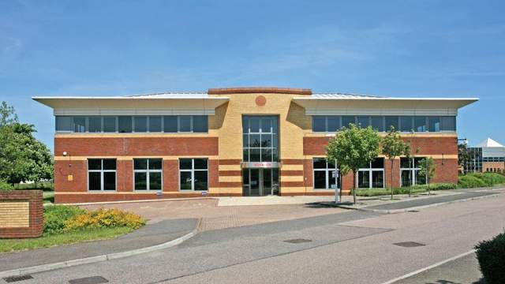


SEEKING A GP TO JOIN OUR FRIENDLY TEAM

We are looking for a GP to complement our friendly team of partners and salaried GPs providing quality care to a growing list of nearly 20,000 patients. We have an opportunity for a GP interested in a 6-session salaried role (or 6-session salaried with view to partnership) in our stable, respected, and forward-thinking training practice.

Based in an excellent location on the Hampshire/Surrey border in Farnborough, we have a fabulous purpose designed building. We are co-located with community nursing, an integrated care team, community midwifery a paramedic home visiting team and the North Hants Urgent Care out of hours facility.

We have developed a model which separates out ‘on the day’ from 'routine' GP care. We aim to provide good online and face to face access for patients with urgent problems but also provide continuity for those with more complex needs.

Although the largest practice in Farnborough, we are a friendly team and work hard to maintain our ‘family atmosphere’. As GPs, we work alongside a highly skilled team of Nurse Prescribers, Paramedic Practitioners, Physician Associates, Practice Nurses, a Mental Health Practitioner, Clinical Pharmacist team and Physiotherapists. A great admin team are employed to support us all.

We have strong links with an active and forward-thinking (Farnborough) Primary Care Network. The locality led home-visiting team of paramedics do > 95% of our daily visits, leaving us to concentrate on end-of-life care.

General Practice is hard work, but we aim to provide high quality care at the same time as sustaining a healthy work/life balance. We are committed to training and career development for GPs, nurses and our growing team of allied health care practitioners.

If you would be interested in an informal chat over coffee and a tour of our state-of-the-art premises, please contact our Practice HR & Training Manager for more information: dawn.hambly@nhs.net https://voyagerfamilyhealth.co.uk

