BURGESS ROAD SURGERY
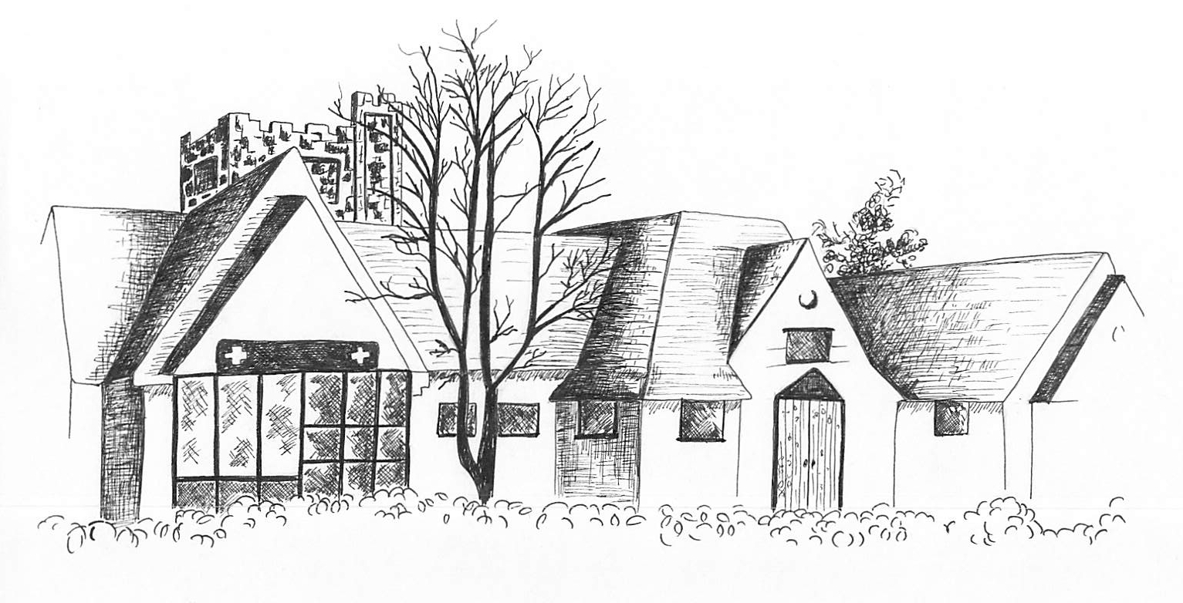
Dr A M Hall 357A Burgess Road
Dr V Shetty Southampton
Dr A Cooper SO16 3BD
Tel: 023 8067 6233

www.burgessroadsurgery.co.uk

Advanced Clinical Practitioner

We are looking to recruit an enthusiastic and experienced Advanced Clinical Practitioner. This is an exciting opportunity to enhance our Clinical Team which currently comprises 7 GP's, 2 x ACPs, 4 Practice Nurses, 1 Health Care Assistant and a large admin team.

Burgess Road Surgery, with over 10,000 patients, is an urban practice situated in the north of the Southampton city. Burgess Road Surgery is a friendly and supportive environment and has a strong commitment to professional development.

As a Team, the Advanced Clinical Practitioner will work each day with the GP’s and nursing team to manage ‘same day’ appointments. We have a varied and diverse population consisting of students, working families/professionals and the retired elderly

As such:
- You will be an Independent Nurse Prescriber with experience in Primary Care; and
- You will hold an MSc/Post Graduate Diploma or equivalent with experience in minor illness.
- We would also be interested in applications from Paramedics.

If you are interested and would like more information or to arrange an informal visit, please contact our Practice Manager, Tamzen Hogben on 02380 676233

Hours; 1 days per week on a Friday. Salary; negotiable and commensurate with experience

Applications: CV and covering letter to Tamzen.Hogben@nhs.net by 30th April 2025

