Support around Drink Spiking

Experiencing drink spiking, needle spiking or spiking of any kind is very traumatic and can take time to process.

Worryingly, one in ten 16 – 25-year olds say they have been a victim of drink or needle spiking and it can happen to anyone and to any drink including non-alcoholic ones. Spiking happens at private parties and festivals as well as at bars and clubs so it’s very important that we know how to support someone who thinks they may have been spiked – you can learn more about the signs and what to do via Preventing drink spiking & what to do if a drink is spiked (life-stuff.org)

Where to go for help

It is very important for the assault to be recorded and for you to be supported:

- To ensure testing and investigation, please report spiking via 101 to the police as soon as possible as some substances leave the body quickly. However, police will test for spiking up to 7 days after the crime.

- If you suspect you have been sexually assaulted, please seek help and support urgently. There are a range of choices via Help after rape and sexual assault - NHS (www.nhs.uk)

- If you need support or someone to talk to about your experience, please contact Victim Support on 0808 16 89 111 (phone or live chat) on the app via Relay UK.

- If you wish to withhold your name and details you can still report to Crime Stoppers via 0800 555 111 or www.crimestoppers-uk.org and they will look into the circumstances and investigate what happened.

Anti-drink spiking resources
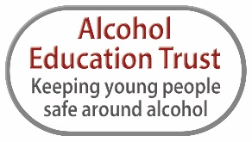
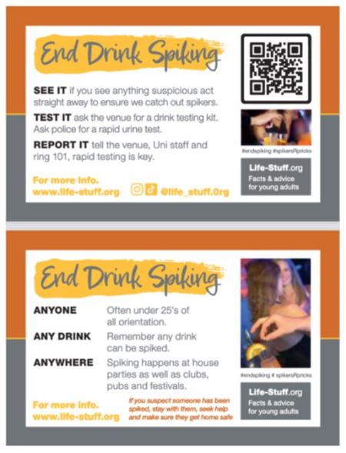
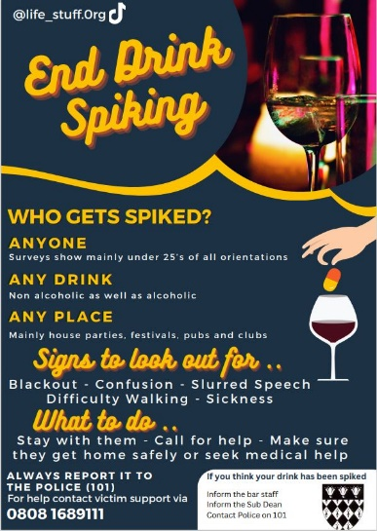

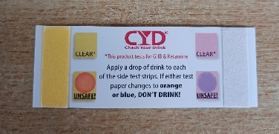

If you are a youth professional, we are able to supply posters, credit card sized awareness cards and drink testing strips free of charge. Please email kate@alcoholeducationtrust.org for further information. You can find further support for ages 16+ via 16+ - Alcohol Education Trust .

SMS link to support for victims of spiking

https://life-stuff.org/spiking-what-to-do/ This links to a page of information for victims of spiking and provides information on what people should do if they have been spiked.

